# The CPT Office 365 VM Setup Guide

**Setup Time**: 4 to 6 hours

**Overview**: Before you can begin to work on the lab exercises for a Critical Path Training course on Office 365, you must first build or acquire a virtual machine (VM) with all the prerequisite software installed by following the instructions provided in this document. Note that with Office 365 development you can use your host machine rather than building a dedicated VM, however, we recommend using a VM so that you can easily move it between host machines and develop and troubleshoot independently of any potential issues you may have with your host machine. This also ensures a clean environment for use during classes thereby avoiding potential issues that could impact your ability to keep up with the class.

This guide will step you through using the Microsoft's Hyper-V to create a new VM and install the Windows 8.1 operating system onto a new VM named **WingtipWorkstation**. You will then download the installation files for **Office 2013, Visual Studio 2015, SharePoint Designer 2013**, **SharePoint Online Management Shell**, and the **Microsoft Azure Active Directory PowerShell Module**. You will then install and configure the various applications. Finally, you will create the trial Office 365 and Azure subscriptions necessary for the class and run some PowerShell commands to validate connectivity.

Once you have completed all the tasks in this setup guide, you will have created a VM that can be used as the starting point for any of the Office 365 Developer courses offered by Critical Path Training.

Please note that the instructions and screenshots in this setup guide are based on Microsoft's Hyper-V Environment. If you plan to build the VM using a different virtualization product other than Hyper-V such as VMWare, you will have to make adjustments as you move through this setup guide for the ways in which your virtualization product differs from Hyper-V.

**A Note from the Author**

A lot of effort has gone into making this guide as complete as possible but there’s always something new cropping up and thus I consider this guide a living entity which will constantly evolve from both my experience as well as yours. So if you find something incorrect or if something just isn’t working (or if you just want to praise the guide – we love praise!) please fill out the Critical Path Training contact form at **http://www.criticalpathtraining.com/contact/** and let us know.

Good luck with your new SharePoint adventure!

- ***Gary Lapointe***

### Task 1: Make Sure You Meet the Hardware Requirements

Before getting started, make sure you have a student workstation that meets the following requirements

1. Make sure you have a host computer running either: Windows 8.1, Windows Server 2012, Windows Server 2012 R2, or Windows Server 2008 R2.
2. Make sure your host computer is configured to run Hyper-V.
3. Make sure your host computer has at least 80GB of free hard drive space
4. Make sure your host computer has enough RAM to run a VM with Windows 8.1
   1. 12GB is the recommended amount of RAM.
   2. 8GB should be considered the minimum amount of RAM to achieve acceptable performance.
   3. Running with less than 12GB of RAM of your host computer will likely lead to poor performance and is not recommended.
5. Make sure your host computer has a connection to the Internet.
   1. The connection can be based on either a network card with a cable plugged in or a wireless connection.

Note that the instructions and the screenshots of the host computer and the Hyper-V environment in this document were created using Windows 8.1. Things will look a bit different with Hyper-V if you are running Windows Server 2012, Windows Server 2012 R2, or Windows Server 2008 R2.

### Task 2: Configure the Hyper-V Network Adapters on the Host Computer

In this task you will configure two Hyper-V network adapters. This task involves creating two virtual switches in Hyper-V that will be used to configure both an internal network adapter and an external network adapter. The internal network adapter will be used to configure a static IP address in the VM. The external network adapter will be used to connect the VM to the Internet.

1. Launch the Hyper-V Manager: **Start** 🡪 **Administrative Tools** 🡪 **Hyper-V Manager**.

The host computer that was used to create the following screenshots is named **HULLABALOO**. Your screen will look a little different because your host computer will have a different name.

1. Create a new virtual switch named **Internal** for an internal network adapter:
   1. In the **Actions** pane on the right-hand side of the screen, click **Virtual Switch Manager**.

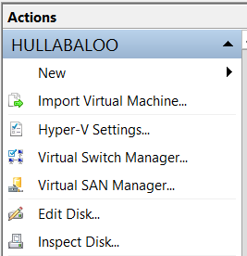

If you are using Windows Server 2008 R2, you are using an older version of Hyper-V which does not use the term **Virtual Switch**. This older version of Hyper-V uses the term **Virtual LAN** instead of **Virtual Switch** so the screenshots shown here will not match.

* 1. In the **Virtual Switch Manager** dialog, create a new virtual switch by selecting **Internal** and then clicking the **Create Virtual Switch** button.

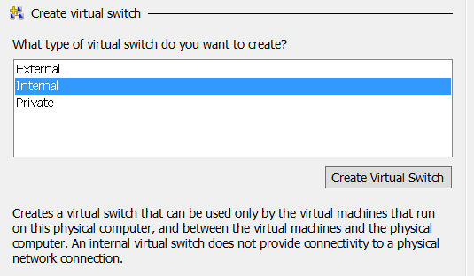

* 1. Configure the new virtual switch with the following properties:
     1. **Name**: Internal
     2. **Connection Type**: Internal network.

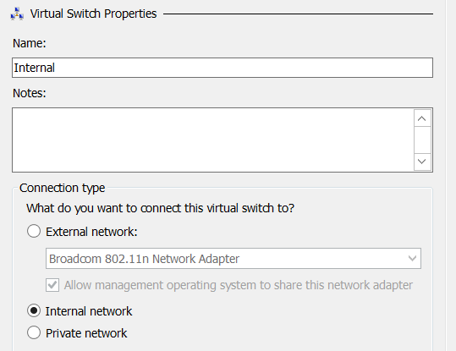

* 1. Click **OK** to save your changes.

In the next step you will create an external virtual switch that will be used to connect the VM to the Internet. You can create this external network switch by using either a network adapter with a network cabled plugged in or a wireless connection on your host computer. All that is required is that you create the virtual switch using a network adapter on your host computer that can connect to the Internet. The Internet connection is an essential part of the setup for this VM because it's required for all Office 365 and Azure activities.

1. Create a new virtual switch named **External** for an external network adapter:
   1. In the **Actions** pane on the right-hand side of the screen, click **Virtual Switch Manager**.



* 1. In the **Virtual Switch Manager** dialog, create a new virtual switch by selecting **External** and then clicking the **Create Virtual Switch** button.

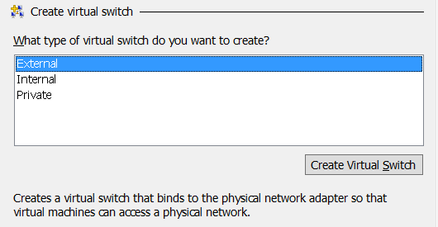

* 1. Configure the new virtual switch with the following properties:
     1. **Name**: External
     2. **Connection Type**: External network.
        1. Make sure to select a network adapter or wireless connection from the host computer in the dropdown menu under the **External network** radio button.

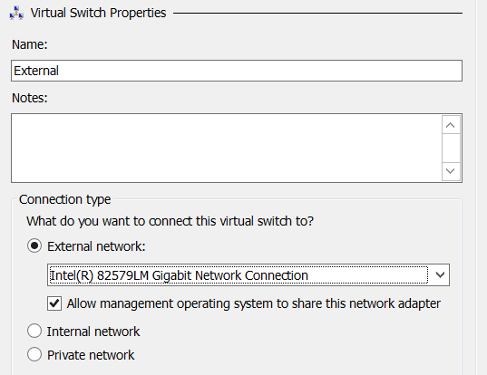

* 1. Click **OK** to save your changes.

### Task 3: Create a new Virtual Machine (VM) using Hyper-V

To complete this task you will create a new VM using the Hyper-V environment.

1. If it is not open, launch **Hyper-V Manager**.
2. On the left-hand side of **Hyper-V Manager**, locate the node with the name of the local host computer and select it.
3. In the **Actions** pane select **New 🡪 Virtual Machine**.
   1. When you execute this menu command, the Hyper-V Manager will launch the **New Virtual Machine Wizard**.

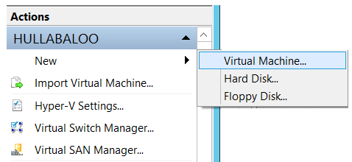

1. The **New Virtual Machine Wizard** begins with the **Specify Name and location dialog.**
   1. Enter a **Name** of **WingtipWorkstation**.
   2. Select a folder path for the **Location** property where the virtual machine files will be stored. Ensure the **Location** path is hosted by a hard drive that has at least 80GB of free space. If possible, configure the **Location** path on a secondary hard drive that is different from the hard drive running the host operating system to improve the performance of your VM.

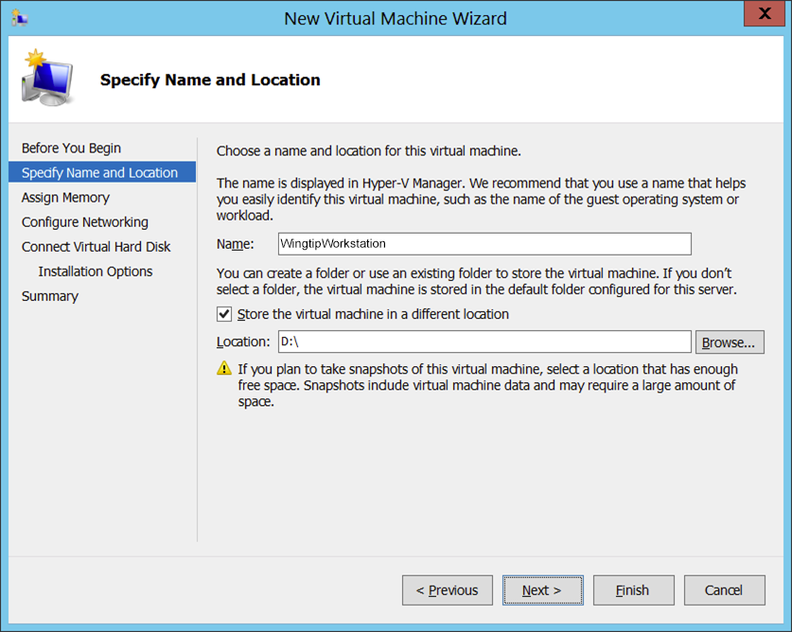

* 1. Click **Next.**

1. In the **Assign Memory** dialog, enter the amount of **Memory** to allocate to the virtual machine.
   1. Determine the amount of memory to use for the VM from the following table.

|  |  |
| --- | --- |
| **If host machine has this much RAM** | **Then configure the VM with this much RAM** |
| 16 GB or more | 14 GB - configure the VM with **14336 MB** of RAM. |
| 14 GB | 12 GB - configure the VM with **12288 MB** of RAM. |
| 12 GB | 10 GB - configure the VM with **10240 MB** of RAM. |
| 10 GB | 8 GB - configure the VM with **8192 MB** of RAM. |
| 8 GB | 6.5 GB - configure the VM with **6656 MB** of RAM. |

* 1. Enter the amount of RAM you calculated in the previous step as the **Startup** memory property. Make sure you enter the number in megabytes (e.g. **14336 MB**). Finally, make sure to leave the **Use Dynamic Memory for this virtual machine** checkbox unchecked. Click **Next** to continue.

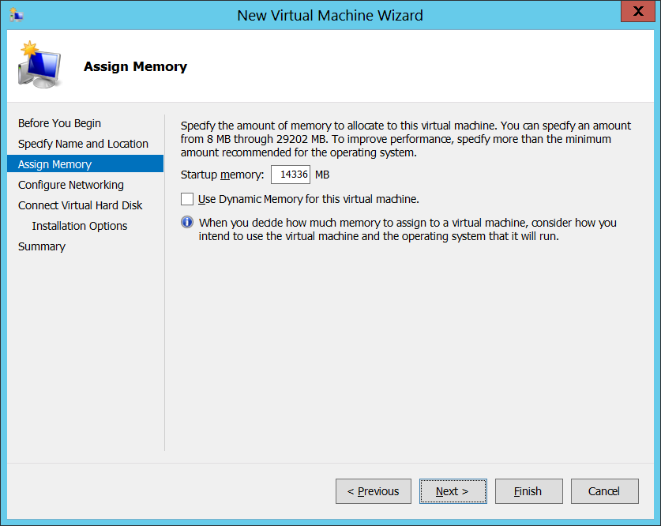

1. In the **Configure Networking** dialog, assign a **Connection** property of the **Internal** and click **Next**.

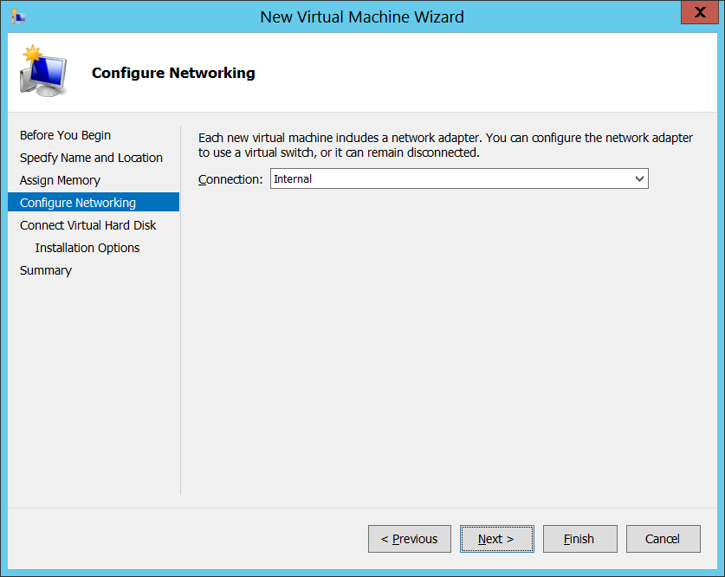

In the next step you will configure the file location for the files Hyper-V uses to store the VM. If possible, configure the VM file location on a separate physical drive that is different than the drive which holds the host computer’s operating system. This is one of the best way to increase the performance of a VM.

1. In the **Connect Virtual Hard Disk** dialog, accept the default option of **Create a virtual hard disk**. Make sure the **Location** is set to a directory in a local hard drive on our host computer that has at least 80 GB of free space. Click **Next**.

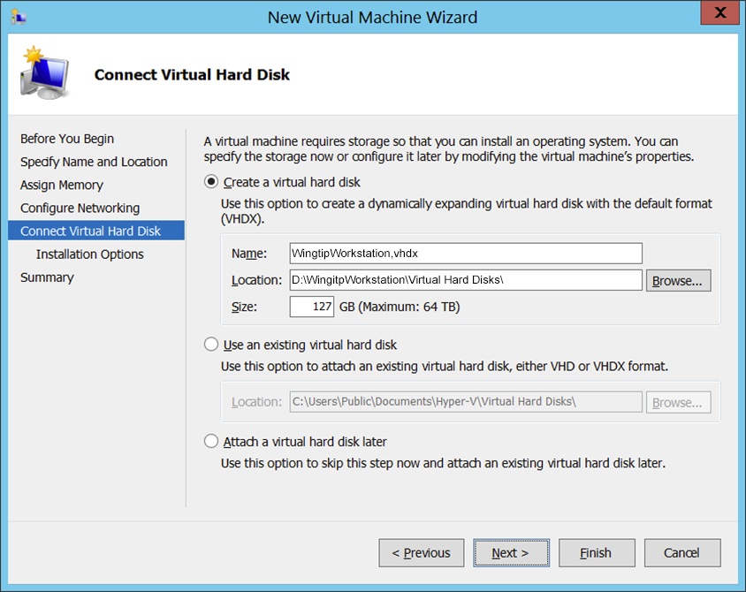

1. In the **Installation Options** dialog, accept the default option which is **Install an operating system later** and click **Next**.

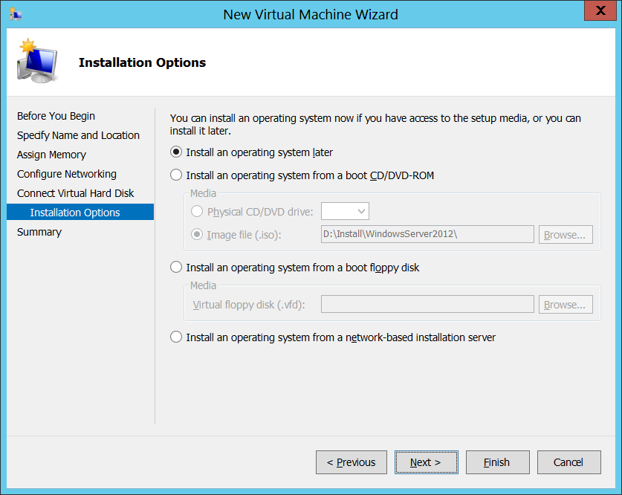

1. On the **Completing the New Virtual Machine Wizard** dialog, review the setting and verify that these settings are what you expected. Click **Finish** to create the new VM.

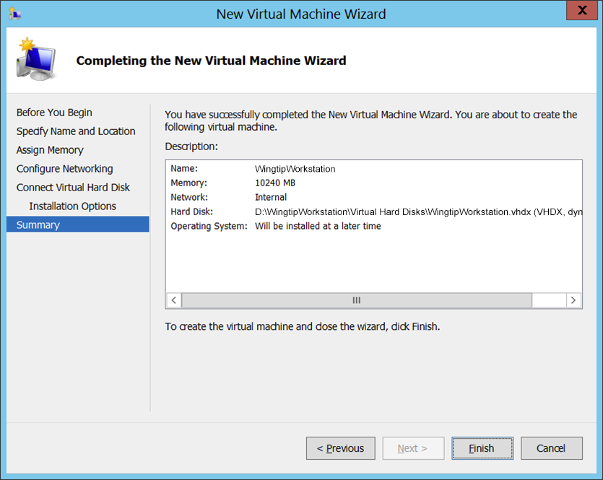

Even though you have finished going through the New Virtual Machine Wizard, there are still two more configuration changes you need to make on the VM before you are ready to install the Windows 8.1 operating system.

1. In the **Hyper-V Manager** window, right-click the VM you just created and select **Settings**:

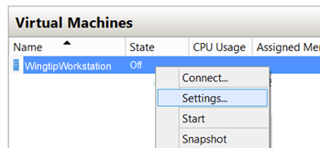

1. In the **Settings for WingtipWorkstation** dialog, complete the following steps
   1. Select the **Processor** setting and increment the **Number of processors** property value from its default value of **1** to the maximum allowable number for your host machine. You can increment the **Number of processors** property value using the up arrow in the spinner control to its right. Depending on the processor capabilities of your host computer, you should be able to increase this property to a value of either **2**, **4** or **8**.

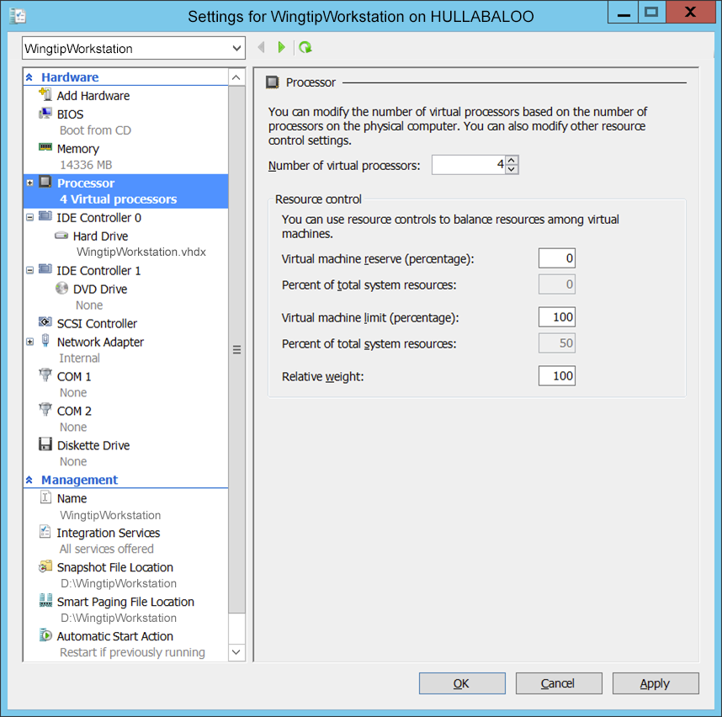

* 1. Click the **Apply** button to save your changes to the **Number of virtual processors** property while leaving the dialog open.

1. Create a second network adapter in the VM.
   1. In the **Settings for WingtipWorkstation** dialog, select **Add Hardware**. Next, select **Network Adapter** and click **Add**:

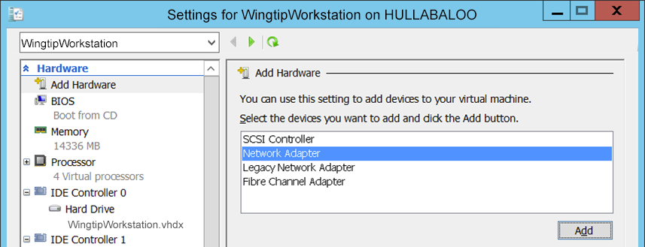

* 1. Once the new Network Adapter has been created, do **not** assign a **Virtual switch** yet. In an upcoming task later in this setup guide you will bind this network adapter to the **External** virtual switch. For now, however, you should leave the **Virtual switch** setting with its default value of **Not connected**.

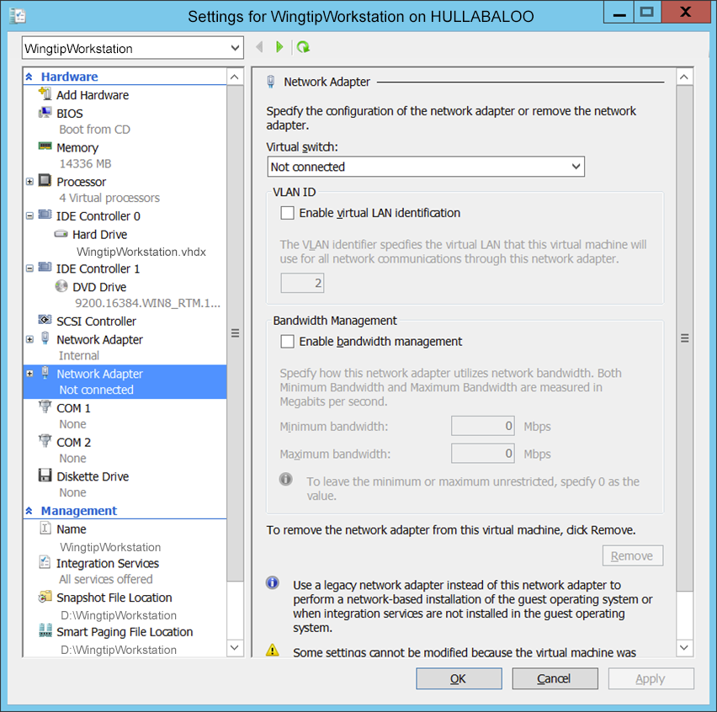

* 1. Click **OK** to save the changes you have made to the VM.

At this point you have created and configured a new VM. You are now ready to install Windows 8.1.

### Task 4: Install Windows 8.1

You will begin this task by acquiring the installation files and optionally a product key for Windows 8.1. After that you will move through the steps of installing the operating system and configuring the VM as a workstation computer named **WingtipWorkstation**.

1. Obtain a copy of the Windows 8.1 install binaries.
   1. Choose between using your own licensed copy of Windows 8.1 or using a free trial version.
      1. Note that downloading the free trial version will require that you have a TechNet or an MSDN subscription.
   2. If you plan to use a licensed copy, acquire the install image (*.iso) for Windows 8.1 and the product key.
   3. If you plan to use a free trial copy of Windows 8.1, follow these steps:
      1. Navigate to the evaluation download page at **http://www.microsoft.com/en-us/evalcenter/evaluate-windows-8-1-enterprise**.
      2. Select **Sign In** under the **Download** section if not already signed in. Sign in using a valid Microsoft Account.
      3. Click **Register to continue** to register for the download. On the registration form, select **64** bit as the version of software to download. Complete the remainder of the registration form and click **Continue** to proceed to the language selection page. Select the appropriate language (we will use English for this guide) and click **Continue** to download the ISO.
      4. When prompted, save the ISO file to an appropriate location.
      5. When you are done, you should have successfully downloaded the .ISO file with the Windows 8.1 installation files to the hard drive of your host computer.
2. Mount the .ISO file so the **WingtipWorkstation** VM recognizes it as a DVD.
   1. Navigate to **Hyper-V Manager**.
   2. Right-click the **WingtipWorkstation** VM and select the **Connect…** command to display the Hyper-V console window for this VM.

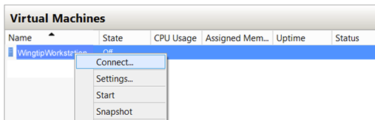

* 1. In the Hyper-V console windows for the **WingtipWorkstation** VM, select the **Insert Disk…** command.

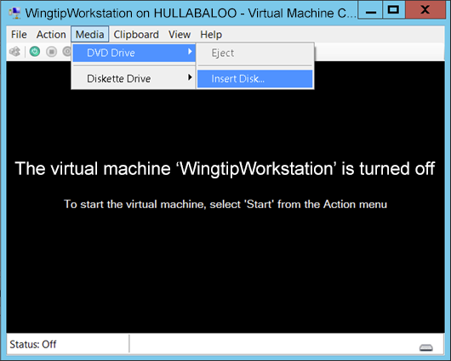

* 1. When the **Open File** dialog appears, enter the path to the .ISO file with the Windows 8.1 installation files.
  2. Click **OK**.

1. Start the **WingtipWorkstation** VM.
   1. In the Hyper-V console windows for **WingtipWorkstation**, select the **Start** command from the **Action** menu to start up the VM.

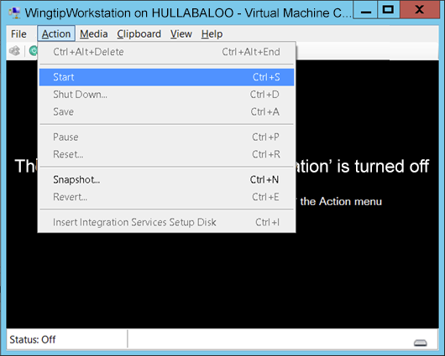

When the **WingtipWorkstation** VM starts, it should automatically start the Windows 8.1 installation program.

1. After the setup program for Windows 8.1 loads, it will prompt you with a dialog asking you to select a language. Accept the default of **English** and click **Install** to continue.

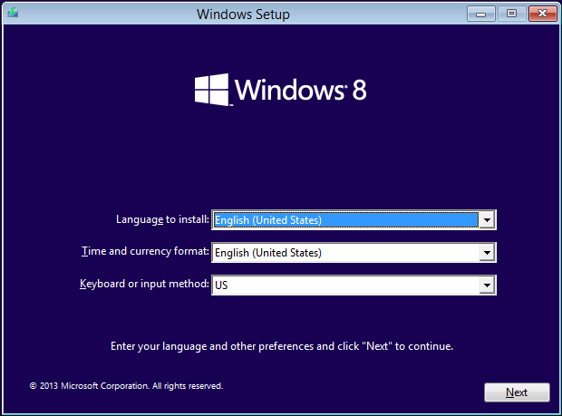

1. At the next dialog, click the **Install Now** button to begin the installation.

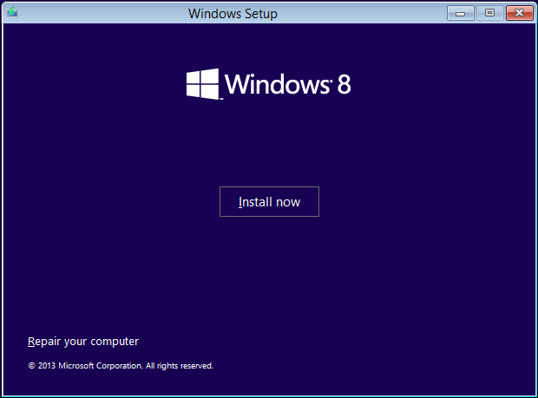

1. Depending on the type of installation files you have for Windows 8.1, you might be prompted with a dialog which asks you to provide your Windows 8.1 product key. If so, enter your product key and click **Next**.

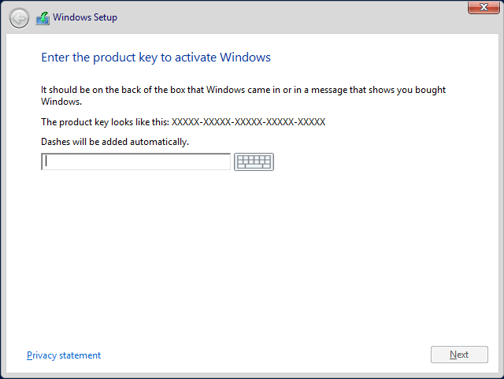

1. On the following dialog, agree to the licensing terms and click **Next**.
2. The next dialog prompts you with the question **Which type of installation do you want?**
   1. Select the installation type of **Custom: Install Windows only (advanced)**
   2. Click **Next**.

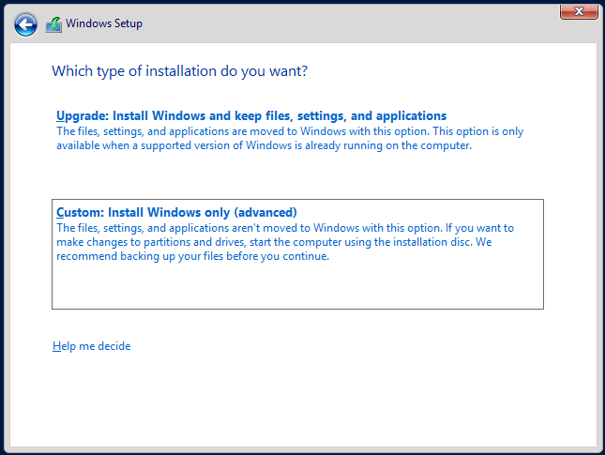

1. The next dialog asks you where you want to install Windows.
   1. Accept the default configuration which uses a location of **Disk 0 Unallocated Space** as shown below.
   2. Click **Next** to continue.

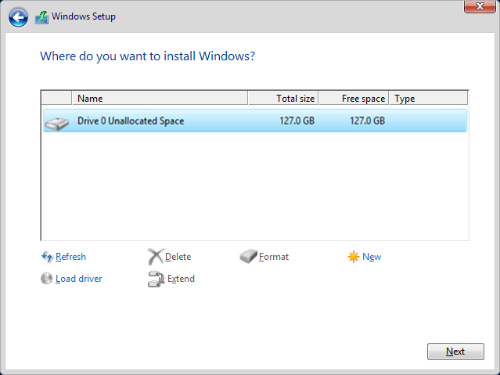

At this point you have given the Windows setup program enough information to install the basic operating system. The Windows 8.1 setup program will now run for several minutes as it copies and expands files and installs Windows features. You now have a few minutes to get a cup of coffee or catch up on email.

1. Wait until the Windows 8.1 setup program completes
2. When the setup program has completed it will prompt you to personalize the environment by specifying a color scheme and a name. Provide a value of **WingtipWrkstn** for the **PC name** field (WingtipWorkstation is too long so we need to abbreviate it):

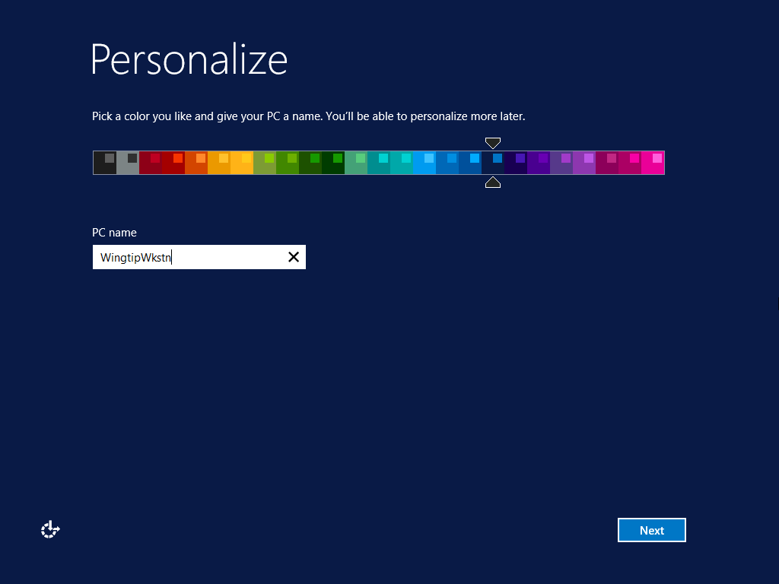

1. On the **Express settings** screen click **Use express settings**:

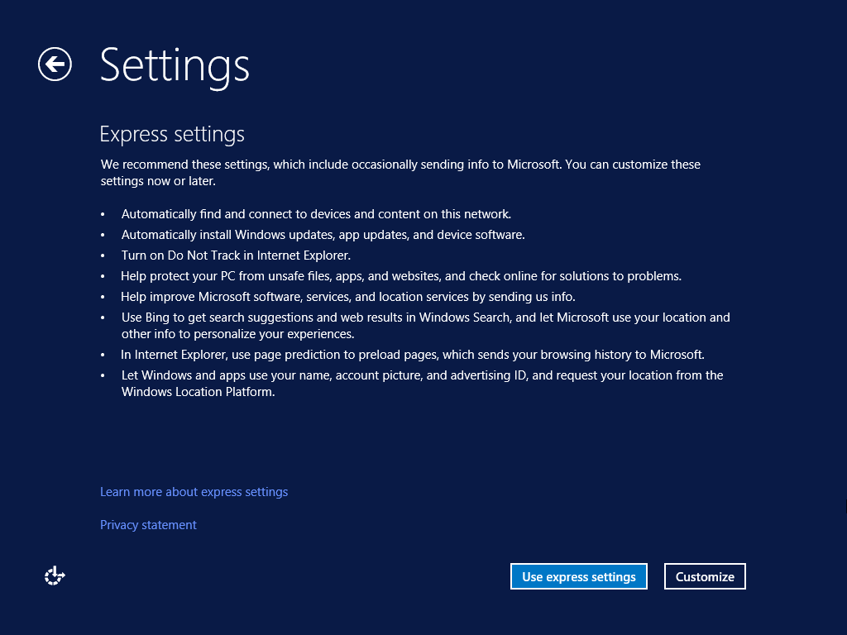

1. On the **Your account** screen specify the user name and password to use when logging in.
   1. Set the user name field to **WingtipUser.**
   2. Set the password to **Password1** and re-enter to confirm.
   3. Set the password hint to **Password One** (or anything that will help you remember the password).
   4. Click **Finish** to complete the basic installation of the operating system.

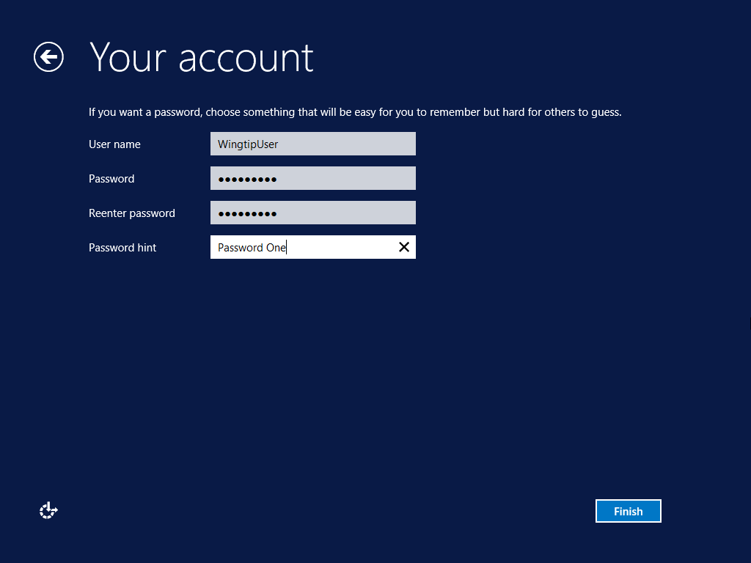

* 1. When you click **Finish** in the previous step, you will be logged off of the VM and the Hyper-V console window will then display the current date and time.



* 1. If you received an error stating that **The Group Policy Client service failed the sign-in** you can safely ignore the error and just click **OK** (see **https://support.microsoft.com/en-us/kb/2976660/en-us** for more information):

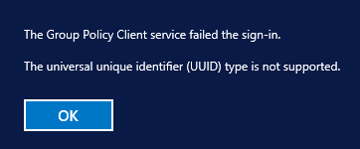

At this point, you have installed the basic operating system for Windows 8.1 but there are several more configuration changes that you must make. Over the next few steps you will complete the required configuration by changing the computer name of the VM and making a few additional changes to the configuration of the operating system.

1. Log onto the VM using the local **WingtipUser** account.
   1. Click anywhere on the screen to proceed to the login screen.
   2. When prompted to log on to the **WingtipUser** account, provide a password of **Password1**.

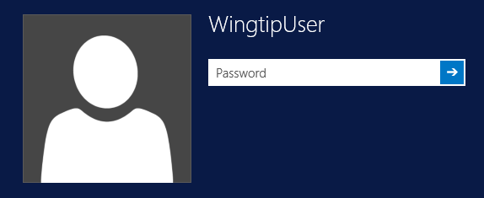

1. Disable the Windows Firewall.
   1. Click the **Windows** icon in the lower left corner to navigate to the Start screen:

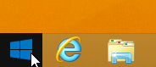

* 1. On the Start screen type **firewall** and select **Windows Firewall**:

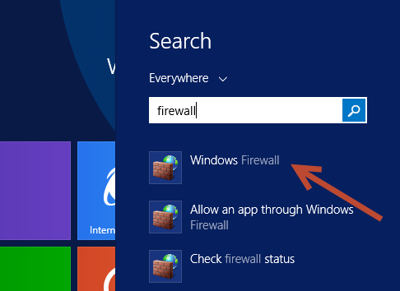

* 1. In the **Windows Firewall** dialog, locate and click the **Advanced Settings** link to display the **Windows Firewall Advanced Settings** dialog.

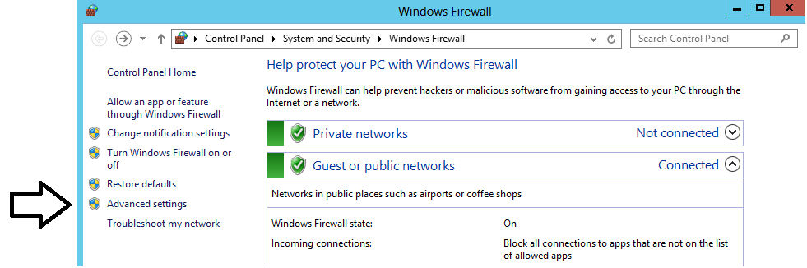

* 1. In the **Windows Firewall Advanced Settings** dialog, you should be able to see that the Windows Firewall for the **Domain Profile**, the **Private Profile** and the **Public Profile** are all enabled. Locate and click the **Windows Firewall Properties** link at the bottom of the **Overview** section to display a tabbed dialog with the title of the **Windows Firewall with Advanced Security on Local Computer**.

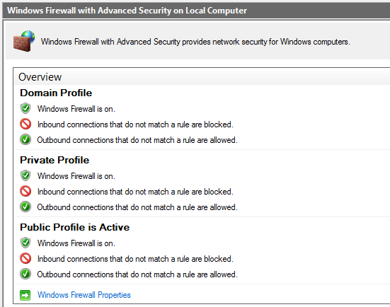

* 1. In the **Domain Profile** tab of the **Windows Firewall with Advanced Security on Local Computer** dialog, change the **Firewall state** property setting from **On** to **Off**. Click **Apply** to save your changes while leaving the tabbed dialog open.

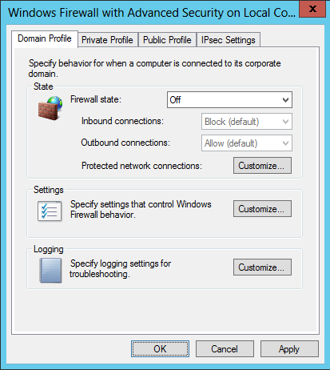

* 1. Once you have configured the **Firewall state** property to **Off** on the **Domain Profile** tab, go to the **Private Profile** tab and then the **Public Profile** tab and follow the same steps to disable the firewall for these profiles as well.
  2. Once you have turned off the firewall for all three profiles, click **OK** to dismiss the dialog. You should be able to verify in the **Overview** section of the **Windows Firewall Advanced Settings** dialog that the Windows Firewall has been turned off for the **Domain Profile**, the **Private Profile** and the **Public Profile**.

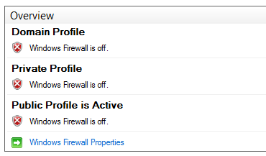

1. Enable Remote Desktop for your VM:
   1. Navigate back to the **Start** screen and type **System**. In the search results click **System** to open the System Properties dialog:

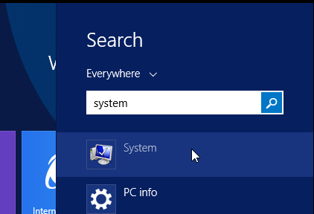

* 1. Click **Remote Settings** in the **System Properties** dialog:

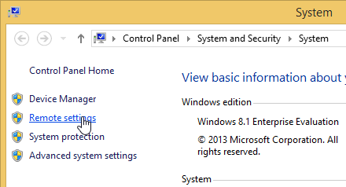

* 1. Configure the remote settings in the **Remote** tab of the **System Properties** dialog.
     1. Select the radio button option **Allow for remote connections to this computer**.
     2. Check **Allow connections only from computers running Remote Desktop with Network Level Authentication**.
     3. Click **OK** to save changes and dismiss the **System Properties** dialog.

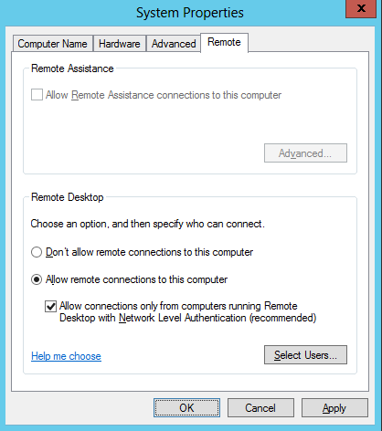

1. Rename the two network connections so you can tell them apart.
   1. Press the **Windows** key on the keyboard to bring up the Windows 8.1 **Start page**.
   2. Your **Start page** should appear as the one shown below.

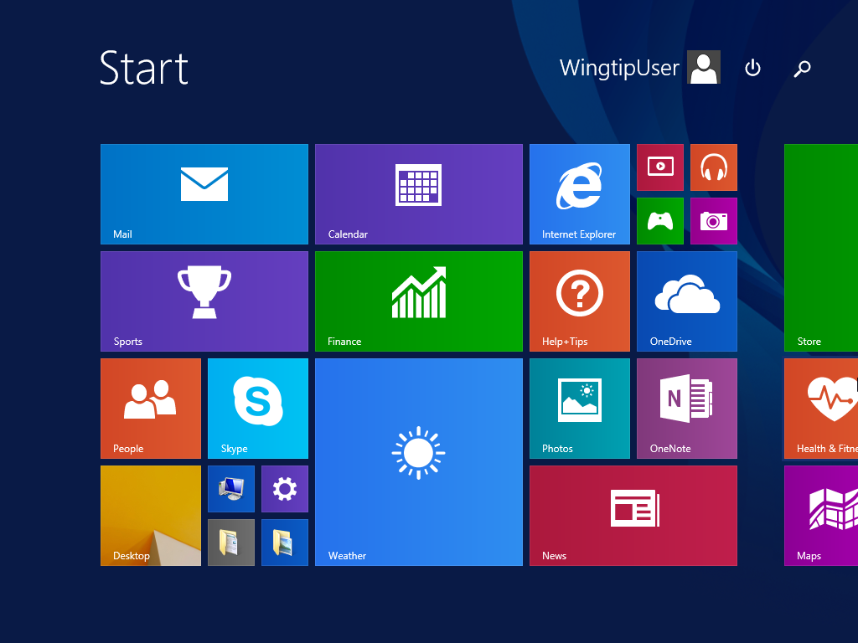

* 1. With the **Start page** showing, go to the keyboard and type in **"View Network Connections"**. You should see that Windows found the **View network connections** page. Click on **View network connections** to navigate to that page.

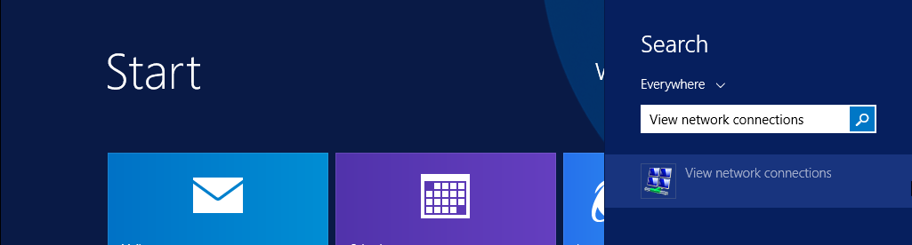

* 1. On the **View network connections** page, you should see that the VM has two network connections. You should also be able to see that one of them is connected and the other one with the big red X is disconnected.

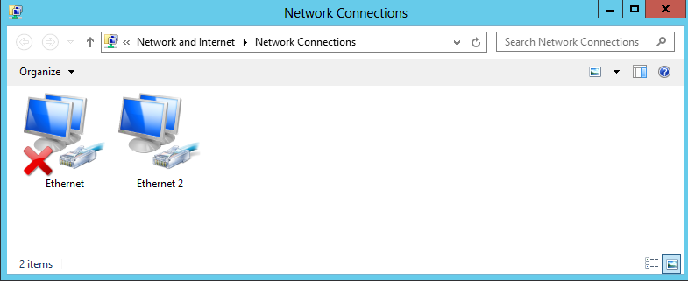

The network connection which is connected is based on network adapter for the VM which is assigned to the virtual switch named **Internal**. The other network connection which is disconnected (e.g. unplugged) has a network adapter that is not currently assigned to a virtual switch. The reason we had you leave the second network adapter unassigned earlier in the setup guide is that it makes it easier to see which network connection is which when initially configuring the VM.

* 1. Right-click the network connection which is connected and select **Rename**. Give it a name of **Internal**.
  2. Right-click the network connection which is disconnected and select **Rename**. Give it a name of **External**.

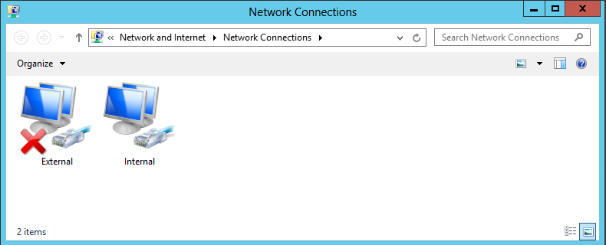

1. Configure a static IP address on **Internal** network connection.
   1. Right-click the **Internal** network connection and select **Properties**.
   2. Uncheck the item **Internet Protocol Version 6 (TCP/IPv6)**
   3. In the **Internal Properties** dialog, select the **Internet Protocol Version 4 (TCP/IPv4)** item and click **Properties**.

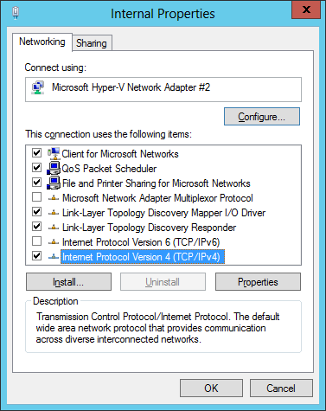

* 1. In the **Internet Protocol Version 4 Properties** dialog, select the option **Use the following IP address** and enter the following configuration settings:
     1. IP Address: 192.168.150.1
     2. Subnet mask: 255.255.255.0
  2. In the **Internet Protocol Version 4 Properties** dialog, select the option **Use the following DNS Server Addresses** and enter the following configuration setting:
     1. Preferred DNS Server: 192.168.150.1

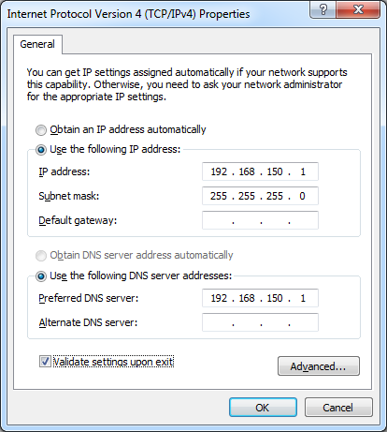

* 1. Click **OK** to accept the IP settings and **Close** the **Internet Protocol Version 4** dialog.

1. Configure the **External** network connection inside the VM to connect to the Internet:
   1. Open the **Network Connections** window if it is not still open using the same steps from the previous step.
   2. Right-click the **External** network connection and select **Properties** to display the **External Properties** dialog.
   3. Uncheck the item **Internet Protocol Version 6 (TCP/IPv6)**
   4. Select the **Internet Protocol Version 4 (TCP/IPv4)** item and click **Properties**.
   5. Enter the following information into the resulting dialog to configure the network connections IP settings:
      1. Select the radio button option **Obtain an IP Address Automatically**
      2. Select the radio button option **Use the following DNS server addresses**.
      3. Set the **Preferred DNS Server** to **4.2.2.4**.

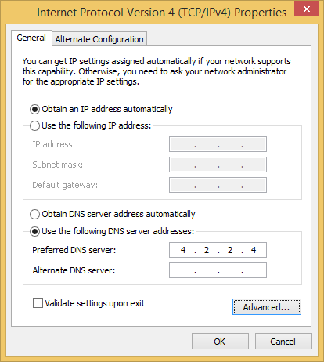

* 1. Click **OK** to accept the IP settings and **Close** the **Internet Protocol Version 4** dialog.

Setting the DNS server addresses for the **External** network connection is important. These settings will ensure that the VM always has a valid DNS server available. The IP address of **4.2.2.4** is a well-known address of a DNS server on the Internet.

1. Reconfigure the VM's network adapter in Hyper-V to bind it to the **External** virtual switch.
   1. Go back to the host computer and open the Hyper-V Manager.
   2. In the Hyper-V Manager window, right-click the VM named **WingtipWorkstation** and select **Settings**.
   3. Select the second Network Adapter, the one that is not connected.
   4. For the **Virtual switch** setting, select **External** and click **OK**. This will effectively connect the **External** network connection in the **WingtipWorkstation** VM to your local LAN and your local DHCP service.

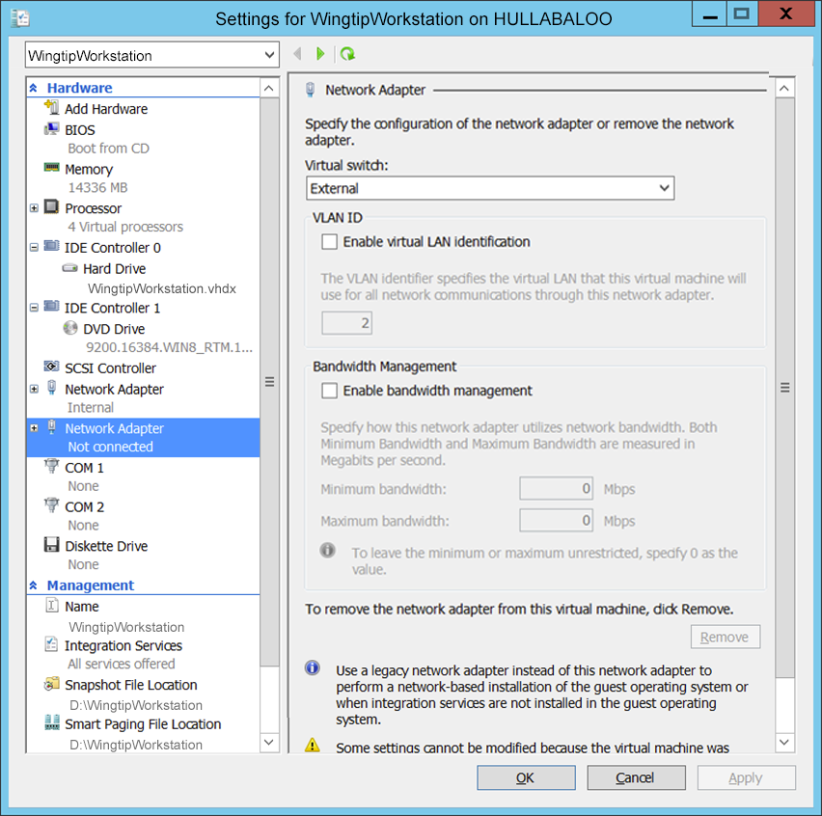

* 1. Return back into the user interface of the **WingtipWorkstation** VM.
  2. Navigate back to the **View network connections** page. You should now see that both network connections show they are connected. In other words, the big red X should have disappeared.

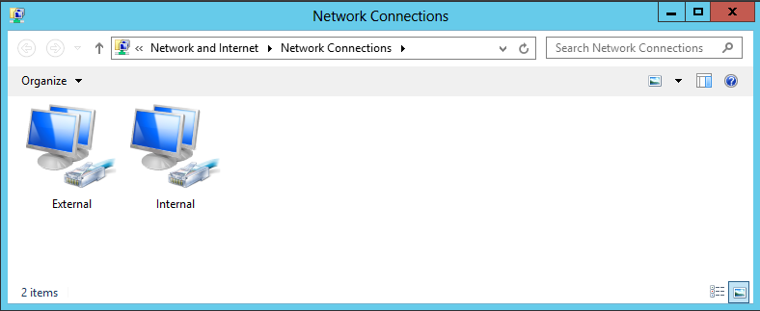

* 1. Refresh the **External** network connection
     1. Select the **External** network connection you just plugged in
     2. With the **External** network connection selected, click the **Disable this Network Device** button in the toolbar.
     3. With the **External** network connection selected, click the **Enable this Network Device** button in the toolbar
     4. When the network connection is re-enabled, Windows uses the **External** network connection to call out to the local DHCP service to acquire an IP address that will make it possible for the **WingtipWorkstation** VM to access the Internet.
     5. Open the Internet Explorer and browse to a site on the Internet such as **http://www.bing.com**. You should be able to browse sites on the Internet without any problems.

1. Configure the Windows Update settings for the **WingtipWorkstation** VM.
   1. Press the **Windows** key on the keyboard to bring up the Windows 8.1 **Start menu**.
   2. With the **Start menu** showing, go to the keyboard and type in **"windows updates"**. You should see that Windows found the **Choose whether to automatically install Windows updates** page. Click on **Choose whether to automatically install Windows updates** to navigate to the page.

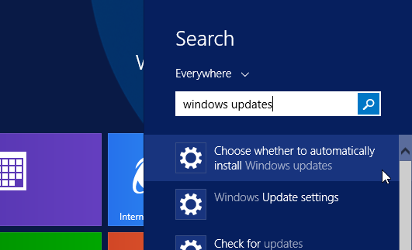

* 1. The **Choose how updates get installed** page shown below provides a dropdown menu that allows you to configure how the **WingtipWorkstation** VM will deal with getting Windows Updates. Select the option for **Never check for updates (not recommended)** and uncheck both checkboxes, as shown in the screenshot below, and then click **Apply** to close the dialog.

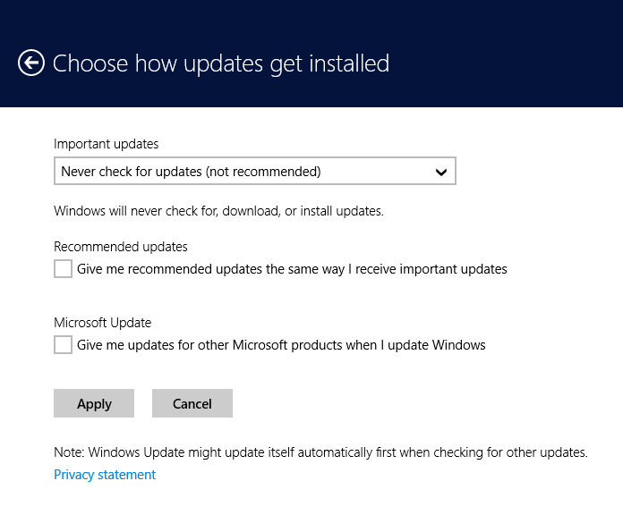

Configuring a computer with a setting of **Never check for updates** isn’t what you should use in a production environment. However, it is usually the good choice for a VM which has been created to provide a lab environment because you don't want to be taken by surprise by Windows updates that change the local computer configuration or interrupt the network connection. Instead of configuring Windows to apply updates automatically, you will now run Windows update manually a single time to apply all the important updates and recommended updates to get the **WingtipWorkstation** VM up to date.

1. Update the **WingtipWorkstation** VM with the latest updates using **Windows Update**
   1. Click on the **Windows** key on the keyboard to bring up the Windows 8.1 **Start menu**.
   2. With the **Start menu** showing, go to the keyboard and type in **"check for updates"**. You should see that Windows found the **Check for updates** page. Click on **Check for updates** to navigate to the **Windows Update** page.

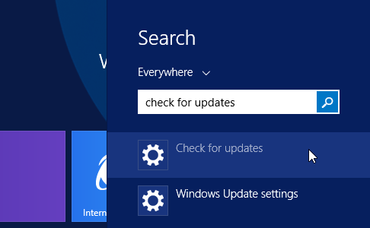

* 1. On the Windows Update page, click the **Check for** **Updates** button. When you click this button, the Windows operating system will communicate with the Windows Update service on the Internet to determine which Windows updates are available for installation.

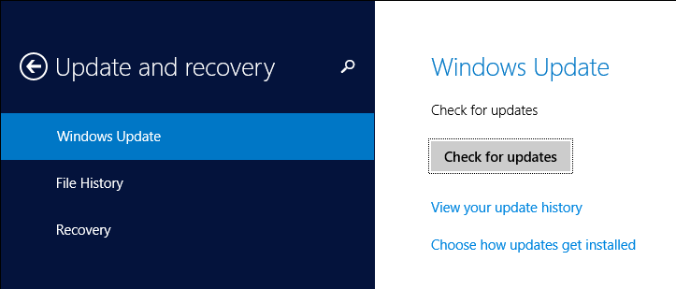

* 1. The **Windows Update** page will prompt you to install any available updates. Click the **Install** button to install all important and recommended updates. If you are prompted, select **I accept the license terms** for any updates that require it.

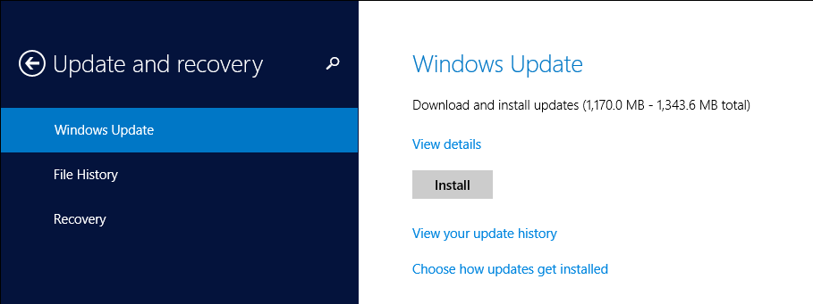

This step can take quite a bit of time so be patient.

* 1. If you are prompted to restart your PC during the Windows Update process, click **Restart now** and wait for the VM to restart. Once the VM restarts, log in as **WingtipUser** and navigate back to the **Windows update** page as you did earlier in this step by searching for **"Check for updates"** on the Windows Start page.

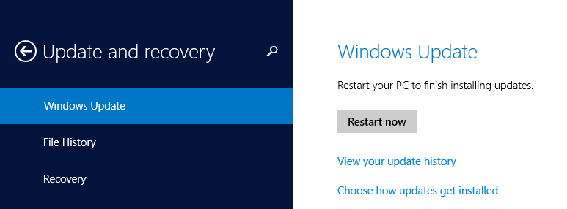

* 1. Once the first round of updates have been installed, click on **Check for updates** button again on the **Windows Update** page. Repeat the process of running Windows Update, checking for updates and installing them (rebooting if required) until the **Windows Update** page reports that **Your PC is up to date** as shown in the following screenshot.

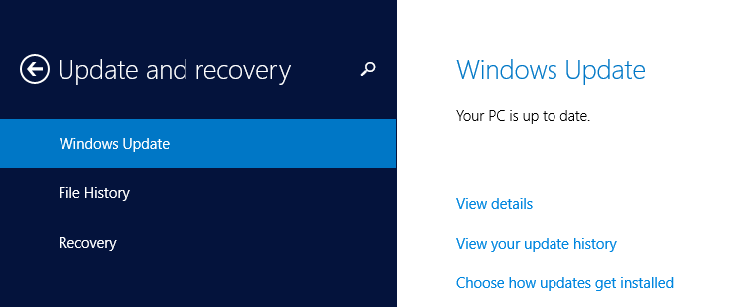

* 1. Once you have applied all the important and recommended updates, close the **Windows Update** page.

1. If you have a Windows 8.1 product key, verify that the Windows operating system is activated.
   1. If you are using the trial version of Windows 8.1, you should skip this step and move ahead to the next step.
   2. Click on the **Windows** key on the keyboard to bring up the Windows 8.1 **Start menu**.
   3. With the **Start menu** showing, go to the keyboard and type in **"Windows Activation"**. You should see that Windows found the **See if Windows is activated** page. Click on **See if Windows is activated** to navigate to the **PC and devices** page.

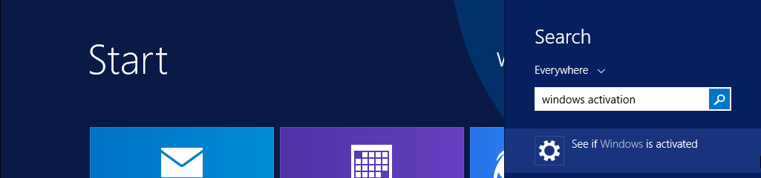

* 1. On the **PC and devices** page, if not activated, click the **Change product key** button to enter your product key and automatically activate your copy of Windows 8.1.
  2. Once you have activated the Windows operating system, close the **Activate Windows** page.

1. Disable User Account Control.
   1. Use the **Windows** key to navigate back to the Start screen.
   2. Type **user account control** to search for the **Change User Account Control settings** application.

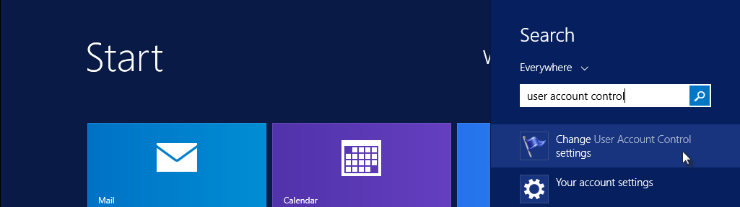

* 1. Change the slider to **Never notify** and click **OK** to save the change.

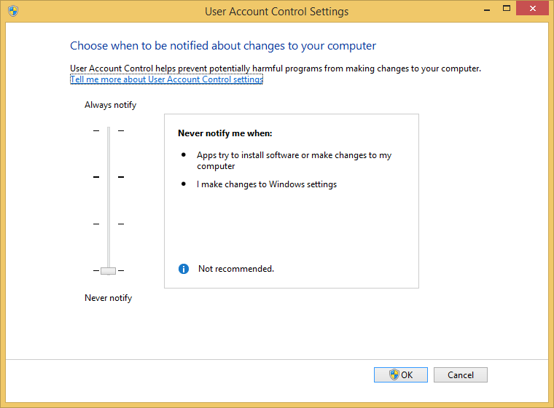

* 1. Reboot the VM for the change to take affect.

At this point you have configured the **WingtipWorkstation** VM with a fully updated version of Windows 8.1.

### ****Task 5: Download Installation Files****

In this task you will download the installation files for the **SharePoint Online Management Shell** and **Azure Active Directory PowerShell Module**, **SharePoint Designer 2013,** and **Fiddler** and make them available on the local hard drive of the **WingtipWorkstation** VM.

1. If not already created, create a new directory named **Install** on the **C:\** drive of the **WingtipWorkstation** VM.
   1. Once created, the path to this directory should be **C:\Install**
2. Download the installation files for **SharePoint Designer 2013**.
   1. Go to the SharePoint Designer 2013 download page at **http://www.microsoft.com/en-us/download/details.aspx?id=35491**.
   2. On the download page, locate the installation file for the 64-bit edition named **sharepointdesigner_64bit.exe**.
   3. Download the installation file to the **WingtipWorkstation** VM at the path **c:\Install\sharepointdesigner_64bit.exe**.
3. Download the installation files for **Fiddler**.
   1. Go to the Fiddler download page at **http://www.telerik.com/download/fiddler** and select the **Fiddler 4** build.
   2. Downloadthe installation file to the **WingtipWorkstation** VM at the path **c:\Install\** **fiddler4setup.exe**
4. Download the installation files for **SharePoint Online Management Shell**.
   1. Go to the SharePoint Online Management Shell download page at **https://www.microsoft.com/en-us/download/details.aspx?id=35588**.
   2. Download the x64 version of the installation file to the **WingtipWorkstation** VM at the path **c:\Install\sharepointonlinemanagementshell_4017-1200_x64_en-us.msi**.
5. Download the installation files for the **Microsoft Online Services Sign-In Assistant**.
   1. Go to the Microsoft Online Services Sign-In Assistant download page at **http://www.microsoft.com/en-us/download/details.aspx?id=41950**.
   2. Download the x64 version of the installation file to the **WingtipWorkstation** VM at the path **c:\Install\msoidcli_64.msi**.
6. Download the installation files for the **Azure Active Directory PowerShell Module**.
   1. Go to **http://go.microsoft.com/fwlink/p/?linkid=236297** and save the file to the **WingtipWorkstation** VM at the path **c:\Install\AdministrationConfig-en.msi**.

At this point you have downloaded the various installation files and made them available on the local hard drive of the WingtipWorkstation VM.

### Task 6: Install Downloaded Files

In this section you will install Fiddler, SharePoint Designer 2013, and the various PowerShell modules.

1. Navigate to **C:\Install.**
2. Double click on the **fiddler4setup.exe** file to install Fiddler.
   1. Click **I Agree** to the License Agreement.
   2. Click **Install.**
   3. Click **Close.**
   4. Internet explorer should appear with a **First Run** Screen for **Fiddler.**
   5. Close **Internet Explorer.**
3. Double click on the **sharepointdesigner_64bit.exe** file to install SharePoint Designer 2013
   1. **Accept** the License Terms and click **Continue.**
   2. Click **Install Now.**
   3. When finished installing click **OK**.
4. Apply Service Pack 1 for Microsoft SharePoint Designer 2013 64-Bit Edition.
   1. Download the update from here: **http://www.microsoft.com/en-us/download/details.aspx?id=42009**
   2. Once the update has downloaded, apply it by double-clicking on the update installation file which is named **spdsp2013-kb2817441-fullfile-x64-en-us.exe**.
   3. Wait until the update has been applied and then close all windows.
5. Double click the **msoidcli_64.msi** file to install the Microsoft Online Services Sign-In Assistant.
   1. **Accept** the License Terms and click **Install.**
   2. When finished installing click **Finish**.
6. Double click the **AdministrationConfig-en.msi** file to install the Azure Active Directory PowerShell Module.
   1. Click **Next**.
   2. **Accept** the License Terms and click **Next**.
   3. Leave the default install location and click **Next**.
   4. Click **Install**.
   5. When finished installing click **Finish**.
7. Double click the **sharepointonlinemanagementshell_4017-1200_x64_en-us.msi** file to install the SharePoint Online Management Shell.
   1. **Accept** the License Terms and click **Install.**
   2. When finished installing click **Finish**.

You have now successfully installed Fiddler, SharePoint Designer 2013, and the various PowerShell modules.

### Task 7: Install and Configure Visual Studio 2015

In this section you will Install Visual Studio 2015 and configure it for use with SharePoint 2013 and Office 365.

1. Create a new directory named **VSInstall** in the **C:\Install** directory of the **WingtipWorkstation** VM.
   1. Once created, the path to this directory should be **c:\Install\VSInstall**

Note that minimally you will need Visual Studio Professional 2015 if you wish to use an MSDN licensed copy for this setup.

1. Download the installation files for the trial edition of Visual Studio 2015.
   1. Go to the Visual Studio 2015 RC download page at **https://www.visualstudio.com/products/visual-studio-2015-downloads-vs**.
   2. Click the **Visual Studio 2015** category in the lower portion of the page and select **Professional 2015**.

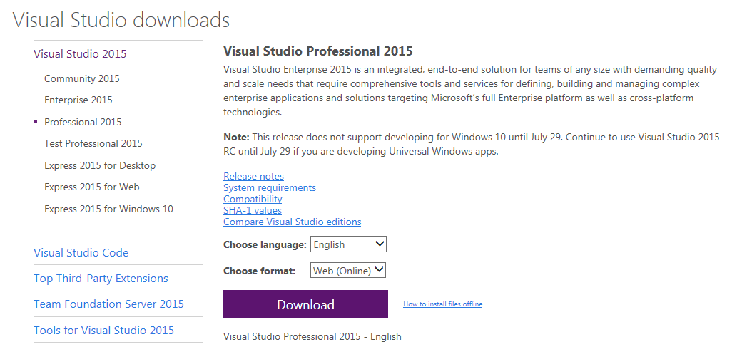

* 1. Click the **Download** link to download to the VM.
  2. If prompted, login using your Microsoft Account.

1. Download the installation file named **vs_professional.exe** to the **c:\Install\VSInstall** directory.
2. Double-click on the **vs_professional.exe** program to install the application.
   1. For the type of installation choose **Custom** and click **Next.**

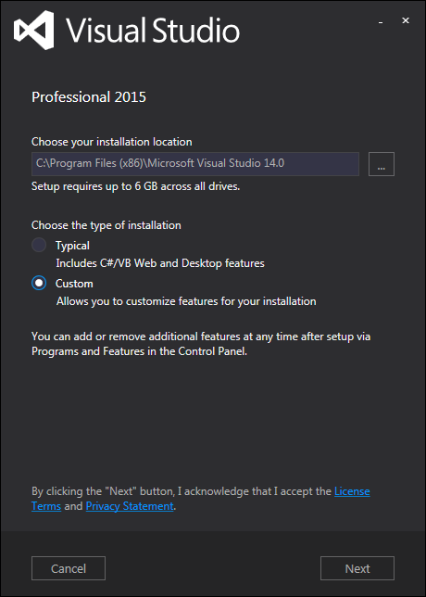

1. On the **Select features** page select the following features and click **Next**:

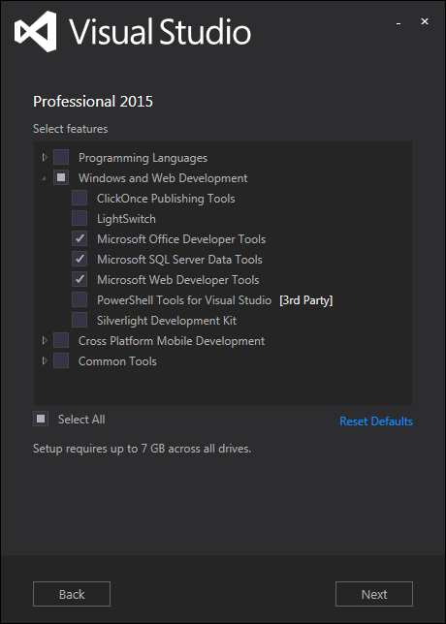

1. On the **Selected features** page click **Install**.
   1. Wait for the install to finish (this will take approximately 20 minutes to finish… relax, grab a muffin and another cup of coffee; decaf this time (don’t want to overdo it…)).
   2. When finished, if prompted to restart the machine click the **Restart Now** button, otherwise, start Visual Studio 2015 by clicking the **Launch** button.
      1. After restarting open Visual Studio 2015 by clicking the Visual Studio 2015 tile in the Start screen.
   3. If asked to sign in click **Not now, maybe later**
   4. Click **Start Visual Studio** to accept the default environment settings
2. Verify that the Office Developer Tools are available.
   1. Click **New Project…** in the left pane:

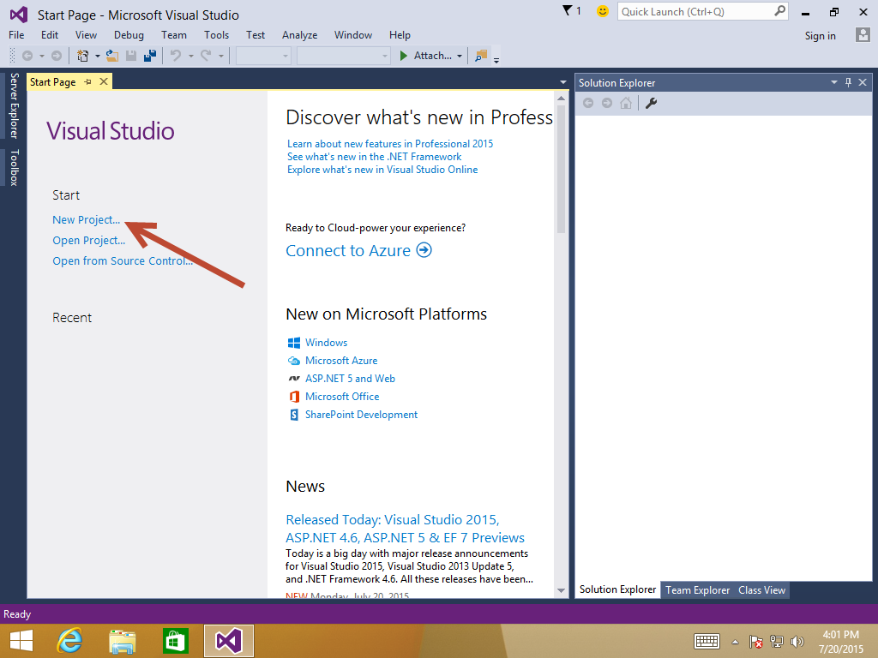

* 1. In the New Project dialog select **Office/SharePoint** from the **Templates > Visual C#** node and verify that the SharePoint and Office templates are available:

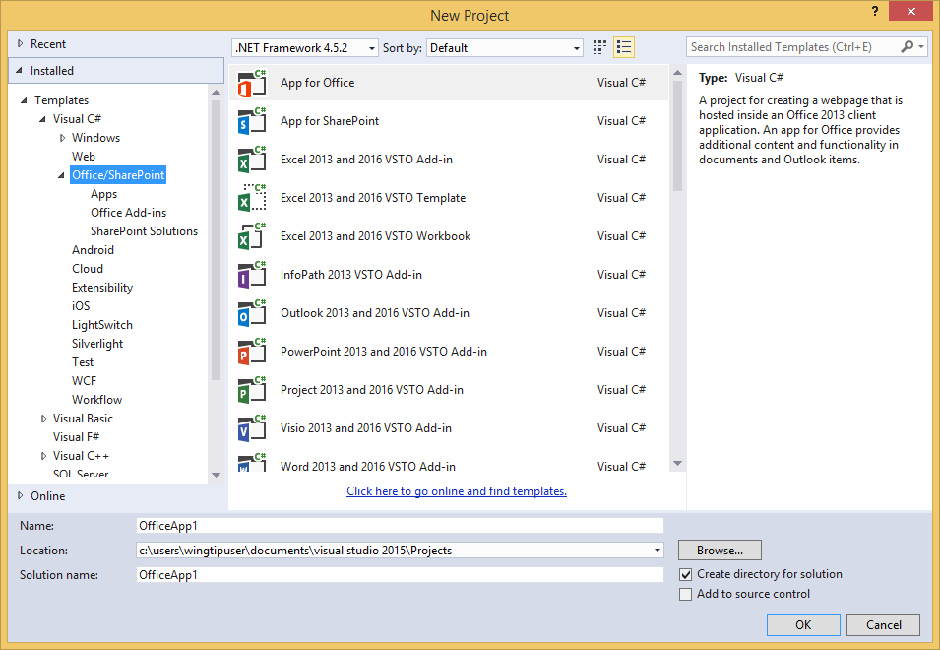

* 1. Click **Cancel** to close the dialog.

### Task 8: Install Office 2013 Professional and Visio 2013

In this step you will install Microsoft Office 2013 Professional. Note that if you are using a trial version of Microsoft Office 2013 Professional, you may wish to wait until closer to your actual class date to install these as you only have a 30 day trial period with these.

1. Obtain a copy of the 64-bit installation binaries for Office 2013 Professional
   1. Choose between using your own licensed copy of Office 2013 Professional or using the free trial version.
   2. If you plan to use a licensed copy, you must acquire the install image (*.iso) for Office 2013 Professional as well as a product key.
   3. If you plan to use a free trial copy of Office 2013 Professional, follow these steps:
      1. Navigate to the Office 2013 Professional trial download site: **http://msdn.microsoft.com/en-US/evalcenter/jj720319.aspx** or you can use an MSDN version of this if you have an MSDN subscription
      2. Download the install files to a location on your host computer (these will typically be in .iso or .img format.
      3. Once this has been downloaded you may either 1) burn this to a blank dvd or 2) attempt to attach to this file. We will attempt to attach the VM to this file using Hyper-V Manager

This download is over a gigabyte in size so it will take some time to download. The amount of time it takes to download will depend upon the speed of your Internet connection.

1. Navigate to the Hyper-V Manager. Right-click the **WingtipWorkstation** VM and select the **Connect…** command to display the Hyper-V console window for this VM.



1. In this step you will configure the VM to load the .ISO file with the Office 2013 Professional installation files as a DVD drive.
   1. In the Hyper-V console windows for the **WingtipWorkstation** VM, select the **Insert Disk…** command.



* 1. When the **Open File** dialog appears, enter the path to the .ISO/.IMG file with the Office 2013 Professional installation files. Click **OK**.

1. Navigate back into the user interface of the **WingtipWorkstation** VM.
2. Depending on your configuration, the Office 2013 Professional installation program in the DVD might or might not start automatically.
   1. If the **AutoPlay** dialog box is open, click run **setup.exe**.
   2. If the **AutoPlay** dialog box is not open, use Windows Explorer to navigate to the DVD drive and execute the **setup.exe** file in the root of the DVD drive.
   3. Wait for the Microsoft Office Professional 2013 installation program to initialize and display the **License Terms** dialog.
3. In the **Microsoft Office Professional 2013 Installation** dialog, complete the following steps:
   1. **Accept** the terms of the license agreement and click **Continue**
   2. Click **Install Now** to install the application
   3. Wait for this to finish and click **Close** when done.
   4. Start Word
      1. Press the **Windows** key and type Word.
      2. Select the **Word 2013** tile
      3. When Word starts you will see an **Activate Office** window
      4. Click **Enter a product key instead**
      5. Enter your product key and click **Install**
   5. Your Office 2013 Professional installation is now ready to use.
4. The final thing we need to do is download and install Visio 2013.
5. Obtain a copy of the 64 bit installation binaries/executable for Visio Professional 2013
   1. Choose between using your own licensed copy of Visio Professional 2013 or use the free trial version.
   2. If you plan to use a licensed copy, acquire the install image (*.iso or .exe) for Visio Professional 2013 and the product key.
   3. If you plan to use a free trial copy of Visio Professional 2013, follow these steps:
   4. Navigate to the Visio Professional 2013 trial download site: **http://technet.microsoft.com/en-US/evalcenter/hh973399?WT%2Eintid1=ODC%5FENUS%5FFX103791368%5FXT104000916**

or you can use an MSDN version of this if you have an MSDN subscription

* + 1. Download the install files to a location on your host computer (these will typically be in .iso, .img, or .exe format.

1. Once this has been downloaded, if you have an iso/img file, you may either 1) burn this to a blank dvd or 2) attempt to attach to this file. We will attempt to attach the VM to this file using Hyper-V Manager  
   (Note: if you have an .exe file skip ahead to step 18.
   1. Navigate to the Hyper-V Manager. Right-click the **WingtipWorkstation** VM and select the **Connect…** command to display the Hyper-V console window for this VM.



* 1. In this step you will configure the VM to load the .ISO file with the Visio Professional 2013 installation files as a DVD drive.
     1. In the Hyper-V console windows for the **WingtipWorkstation** VM, select the **Insert Disk…** command.



* + 1. When the **Open File** dialog appears, enter the path to the .ISO/.IMG file with the Visio Professional 2013 installation files. Click **OK**.
  1. Navigate back into the user interface of the **WingtipWorkstation** VM.
  2. Depending on your configuration, the Visio Professional 2013 installation program in the DVD might or might not start automatically.
     1. If the **AutoPlay** dialog box is open, click run **setup.exe**.
     2. If the **AutoPlay** dialog box is not open, use Windows Explorer to navigate to the DVD drive and execute the **setup.exe** file in the root of the DVD drive.
     3. Wait for the Microsoft Visio Professional 2013 installation program to initialize and display the **License Terms** dialog

1. Now let’s install and activate Visio Professional 2013
   1. **Accept** the terms of the license agreement and click **Continue.**
   2. Click **Install Now.**
   3. Click the **Close** button.
   4. Press the **Windows** key and type **Visio**.
   5. Select the Visio Professional tile.
   6. When Visio starts you will see an **Activate Office** window.
   7. Click **Enter a product key instead.**
   8. Enter your product key and click **Install.**
   9. Your Visio Professional 2013 installation is now ready to use.

### Task 9: Create an Office 365 Trial Tenant

In this step you will create a trial Office 365 Enterprise E3 Tenant.

1. Navigate to **https://go.microsoft.com/fwlink/p/?LinkID=403802&culture=en-US&country=US**.
   1. Fill out the form with your personal information and click **Next** to continue to step 2. The information you provide here will be used throughout your tenant so if you do not wish for your actual company name to be utilized then provide something you are comfortable with utilizing.
   2. Provider a user ID (such as your first name and/or last name) and a company name and password. For the company name field you may wish to simply use your first and/or last name with a number which you can increment each time you have to create a new trial account (e.g. EricClapton1.onmicrosoft.com). Don’t use your actual company name as that may cause some conflict when your company decides to create their own official tenant. Throughout the remainder of this guide you will see a **[your tenant]** placeholder value which you should replace with the value specified for the company name.
   3. Click **Next** to continue to step 3.
   4. Complete the validation form in step 3 by entering in the code provided via text or voice and click **Create my account** to provision the new tenant.
   5. When complete, click the **You’re ready to go…** link to proceed to the portal welcome screen.

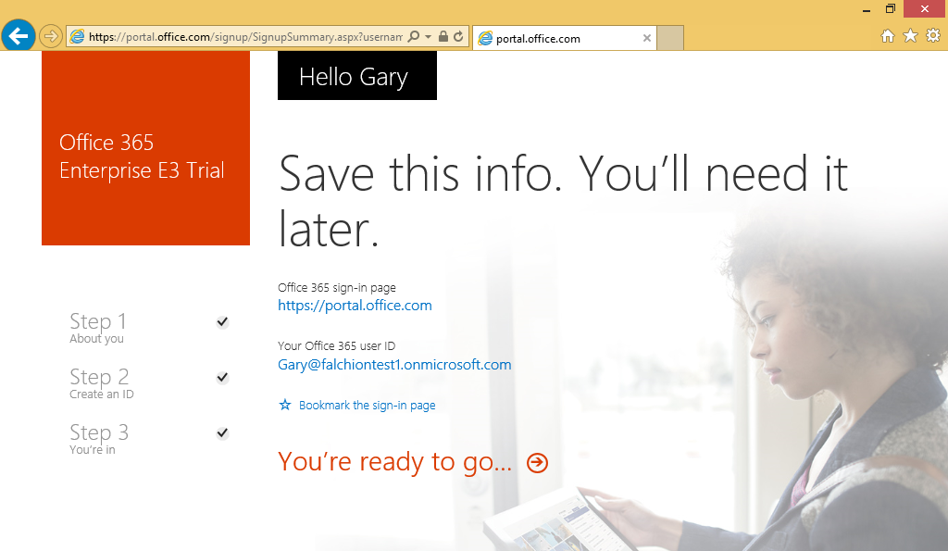

* 1. On the portal welcome screen you will notice that it is slowly setting up each of the individual services that make up your new Office 365 tenant. Click the Admin tile to proceed to the Office 365 Tenant Admin site.

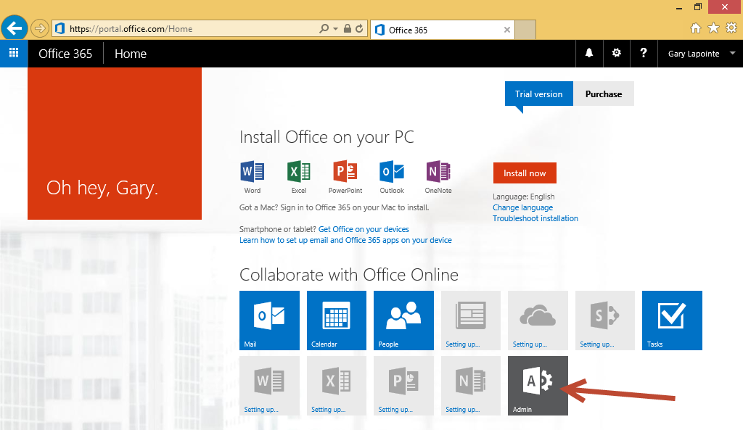

* 1. Verify that the admin center loads.

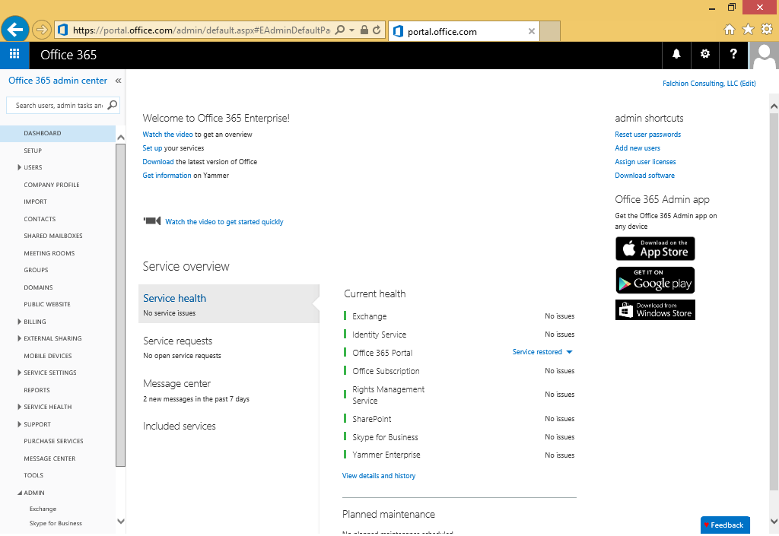

1. Add a Power BI trial account to the subscription.

The trial account for Power BI is for just one month so be sure you do this close enough to your class start time so that the trial does not expire before your class is complete.

* 1. In the Office 365 admin center, click the **Purchase Services** link in the left column.

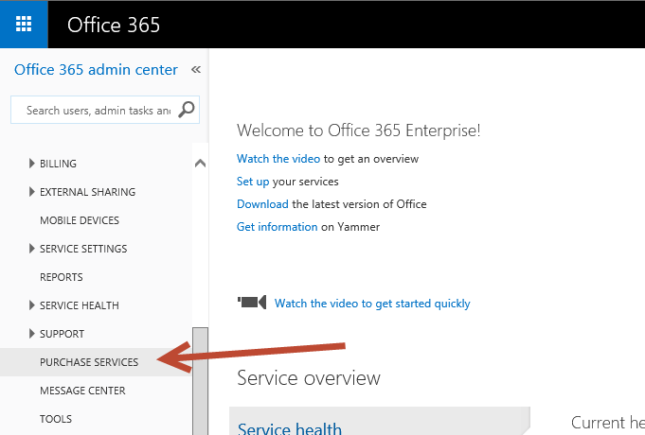

* 1. Locate the **Power BI for Office 365 with SharePoint Online (Plan 2) with Yammer** tile, hover over the ellipses (…) in the bottom of the tile and click **Start free trial**.

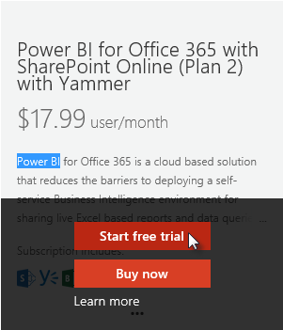

* 1. On the **Check out** page click **try now** to add the subscription to your tenant.
  2. Click **continue** on the **order receipt** page.

1. Assign the Power BI license to your account.
   1. In the Office 365 admin center, expand the **Users** node in the left column and click **Active Users**.
   2. Check the box next to your account and click **Edit** next to **Office 365 Enterprise E3** in the tool pane on the right.

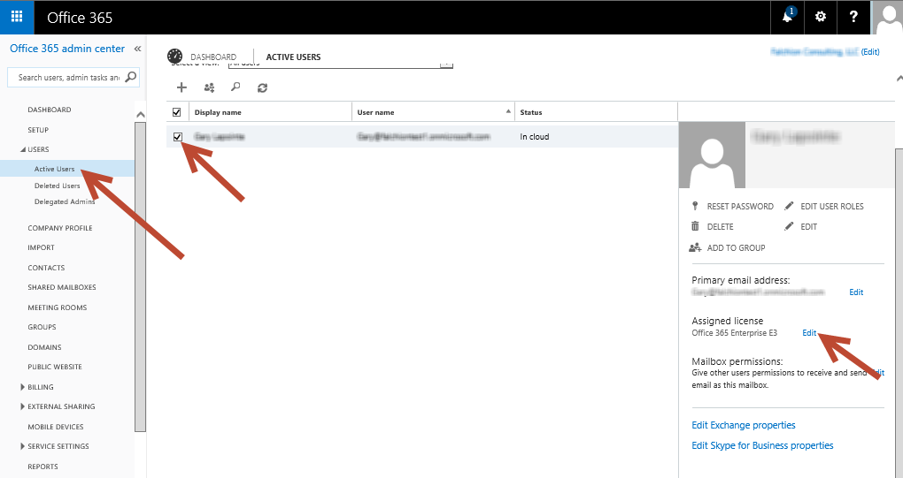

* 1. Expand **Microsoft Power BI for Office 365** and select the two Power BI options.

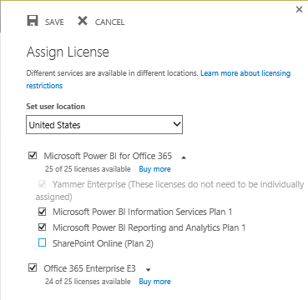

* 1. Click **Save** to complete the assignment.

1. Open the Outlook web client and verify you can send and receive emails.
   1. Navigate to **https://outlook.office365.com** or click the **Mail** icon in the Application Launcher accessible via the **Waffle** **Button**.

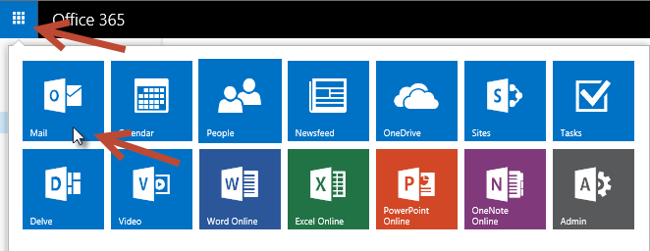

* 1. If prompted, specify your language and time zone for Outlook.

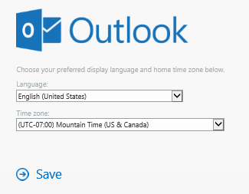

* 1. In the Outlook Web Client, click **New** to create a new email and specify the **To**, **Subject**, and email content. Be sure to provide a valid email address
  2. Click **Send** to send the email.

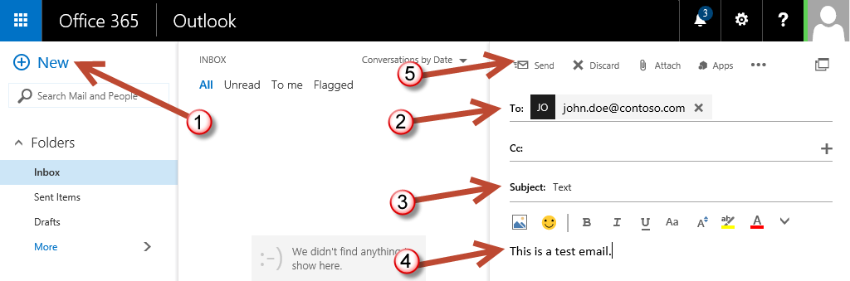

* 1. Check the email account you sent the email to and verify that you received the email.
  2. Reply to the email to verify that you can send an email to your new account.
  3. Return to the Outlook Web Client and verify receipt of your reply.

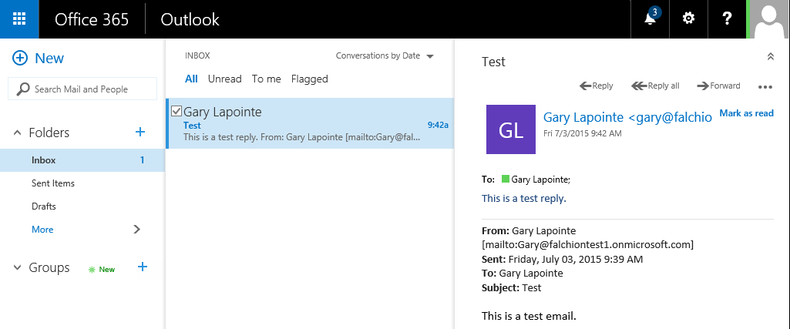

### Task 10: Create an Azure Trial Account

In this step you will create a trial Azure subscription.

1. Navigate to **https://azure.microsoft.com/en-us/pricing/free-trial/**.
   1. Click the **Try it now** button to go to the sign up screen.

Note that you should still be logged in with the account created during the Office 365 trial creation, however, if you are not then make sure you log in using that account – this is critical to ensure that the Azure account is properly associated with your Office 365 tenant. Also, if you attempt to create more than one Azure trial account using the same personal information, credit card and/or verification number you may get an error as you are only allowed to create one trial account (Microsoft will not share what the specific combination of data is that constitutes a duplicate trial account).

* 1. On the sign up page provide the required information including the verification and credit card details. The credit card information is required but you will not be charged anything unless you explicitly choose to upgrade to a paid offering.
  2. Click **Sign up** to continue.

### Task 11: Verify PowerShell Connectivity

In this step you will use the previously installed PowerShell modules to verify connectivity and create a new Site Collection.

1. Use the **Windows** key to navigate to the Start screen and type **azure** to search for the Windows Azure Active Directory Module for Windows PowerShell.

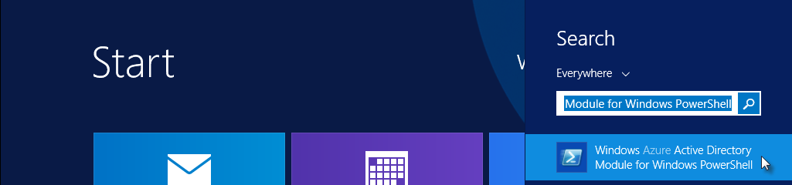

* 1. Click the **Windows Azure Active Directory Module for Windows PowerShell** application to open the PowerShell console window.
  2. Type the following command to store your credentials and establish a connection to the tenant (use the same username and password you used when creating the Office 365 trial - we’ll use these credentials later so keep the console window open when complete):

$cred = Get-Credential

Connect-MsolService -Credential $cred

* 1. Run the following command to retrieve your company information that you provided when creating the tenant

Get-MsolCompanyInformation

1. Now that you’ve verified your Azure Active Directory PowerShell module can connect to your tenant you can now validate that the SharePoint Online Management Shell module works.
   1. It’s not necessary to load the SharePoint Online Management Shell as the PowerShell module we need will be loaded automatically when you attempt to use one of the applicable cmdlets.
   2. Run the following command to connect to your SharePoint Online tenant:

Connect-SPOService -Url https://[your tenant]-admin.sharepoint.com -Credential $cred

* + 1. Be sure to replace **[your tenant]** with the value you provided when creating your Office 365 tenant (this will be the same value that is preceding **onmicrosoft.com** in your login).
  1. Run the following command to retrieve the list of existing Site Collections:

Get-SPOSite -Limit All | select Url

1. Create a new Site Collection using the **New-SPOSite** cmdlet.
   1. Be sure to replace **[your tenant]** with the value you provided when creating your Office 365 tenant:

New-SPOSite -Url https://[your tenant].sharepoint.com/sites/Test -Owner $cred.UserName -StorageQuota 1000 -Title "Test Site" -Template "STS#0"

* 1. This command could take several minutes to complete.

1. Verify creation of the Site Collection.
   1. Navigate to **https://[your tenant]-admin.sharepoint.com**
   2. You should see your new Site Collection listed. Click the URL of the Site Collection to open its properties.
   3. Click the Web Site Address to open the Site Collection in a new window.

### Task 12: Create a New User

In this step you will use Windows PowerShell to create a new test user and assign a license to that user.

1. If not already created, create a new directory named **Scripts** on the **C:\** drive of the **WingtipWorkstation** VM.
   1. Once created, the path to this directory should be **C:\Scripts**
2. Use the **Windows** key to navigate to the Start screen and type **powershell ise** to search for the Windows PowerShell ISE.

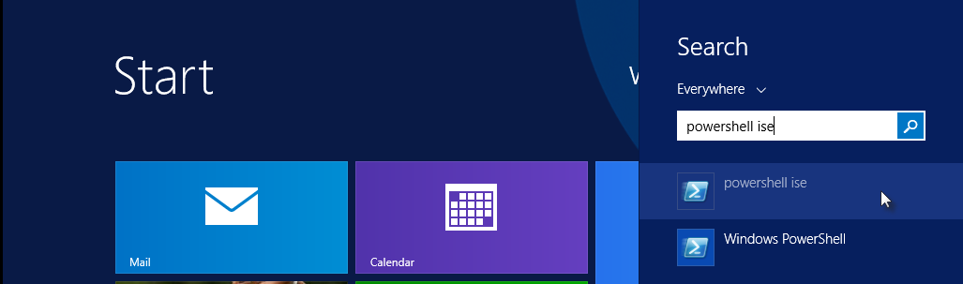

* 1. Click the **PowerShell** **ISE** application to open the PowerShell ISE window.

1. Click the **New** icon to create a new script file.

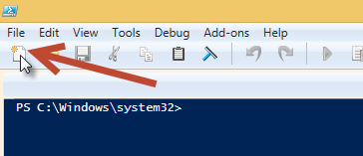

1. Enter the following script:
   1. Note the tick marks (`) to denote a new line when calling the various cmdlet.

function New-Student($username, $password, $displayName, $alternateEmail) {

# Get the tenant name (license prefix).

$tenant = (Get-MsolAccountSku)[0].AccountSkuId.Split(":")[0]

# Create the user

New-MsolUser -UserPrincipalName $username `

-DisplayName $displayName `

-UsageLocation "US" `

-UserType Member `

-LicenseAssignment "$tenant`:ENTERPRISEPACK" `

-AlternateEmailAddresses $alternateEmail `

-Password $password `

-PasswordNeverExpires $true

# Create a license options object that removes SharePoint Online Plan 2 from Power BI Standalone.

$licenseOption = New-MsolLicenseOptions -AccountSkuId "$tenant`:POWER_BI_STANDALONE" `

-DisabledPlans "SHAREPOINTENTERPRISE"

# Add the Power BI license to the user.

Set-MsolUserLicense -AddLicenses "$tenant`:POWER_BI_STANDALONE" `

-LicenseOptions $licenseOption `

-UserPrincipalName $username

}

1. Click the **Save** icon to save the file as **C:\Scripts\New-Student.ps1**.

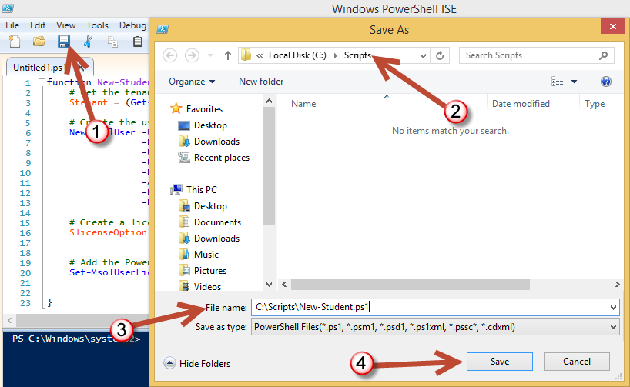

1. Click **Save** to save the file.
2. Use the **Windows** key to navigate to the Start screen and type **azure** to search for the Windows Azure Active Directory Module for Windows PowerShell.



* 1. Click the **Windows Azure Active Directory Module for Windows PowerShell** application to open the PowerShell console window.

1. Ensure that the current execution policy allows the execution of scripts by running the following command:

Set-ExecutionPolicy Bypass -Force -Scope CurrentUser

1. Load the **New-Student** function by executing the following command which uses PowerShell’s dot source notation (note the space after the first dot):

. C:\Scripts\New-Student.ps1

1. Run the following command to connect to your tenant:

$cred = Get-Credential

Connect-MsolService -Credential $cred

1. Run the following command replacing the **-username** and **-alternateEmail** parameters with appropriate values for your new tenant.
   1. The username should be in the form <user>@<your tenant>.onmicrosoft.com.
   2. The alternate email should be a valid email address that you have access to.
   3. Enter the entire command on one line.

New-Student -username "student1@yourtenant.onmicrosoft.com" -password "Password1" -displayName "Student One" -alternateEmail "john.doe@contoso.com"

1. Verify account creation in the Office 365 admin center.
   1. Navigate to **https://portal.office.com/admin/default.aspx** and click **Active Users** within the **Users** node.
   2. Select the checkbox next to the new user and click **Edit** under the **Assigned license** section in the right panel.

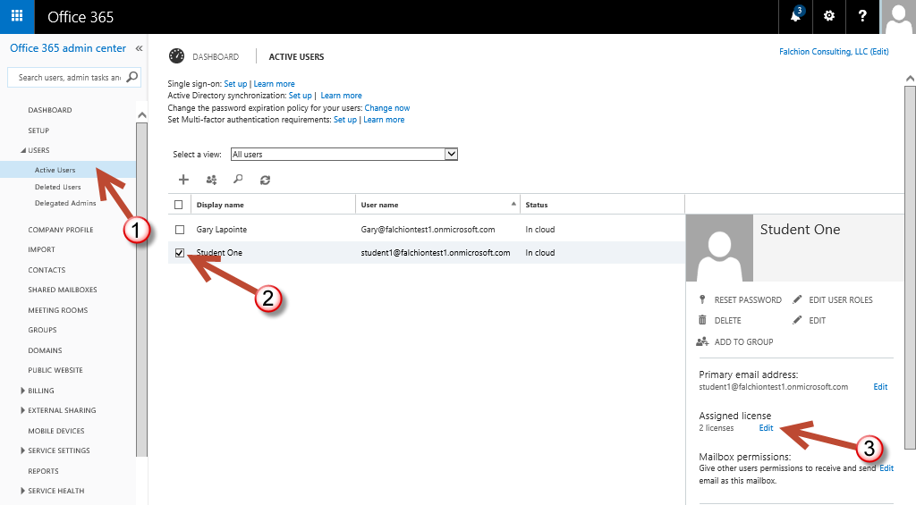

* 1. Verify the license assignment is as shown:

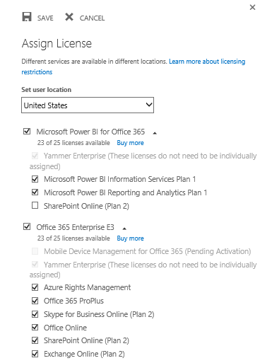

* 1. Click **Cancel** to close the Assign license dialog.

### Task 13: Create a Unified Group

In this step you will connect to Exchange Online to create a new Unified Group.

1. Use the **Windows** key to navigate to the Start screen and type **powershell** to search for Windows PowerShell.

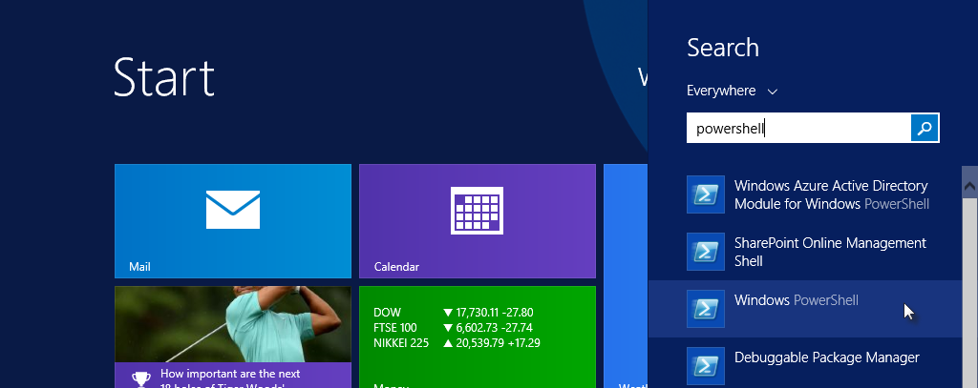

* 1. Click the **Windows PowerShell** application to open the PowerShell console window.

1. Create a new remote PowerShell session by running the following command:

$session = New-PSSession -ConfigurationName Microsoft.Exchange -ConnectionUri "https://outlook.office365.com/powershell-liveid/" -Credential $cred -Authentication Basic –AllowRedirection

1. Run the following command to import the available cmdlets into the current PowerShell runspace:

Import-PSSession $session

1. User the imported New-UnifiedGroup cmdlet to create a new Unified Group:

New-UnifiedGroup -DisplayName "My First Group" -Alias "MyFirstGroup" -AccessType Public

1. Use the Remove-PSSession cmdlet to end the remote session:

Remove-PSSession -Session $session

1. Verify group creation.
   1. Return to the Office 365 admin center if not already open: **https://portal.office.com/admin/default.aspx**
   2. Click the **Waffle** **Button** in the top left and select **People**.

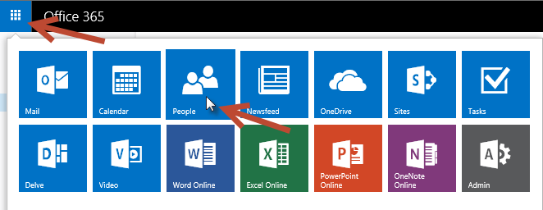

* 1. In Outlook, verify that **My First Group** is present and click it to view the Group.

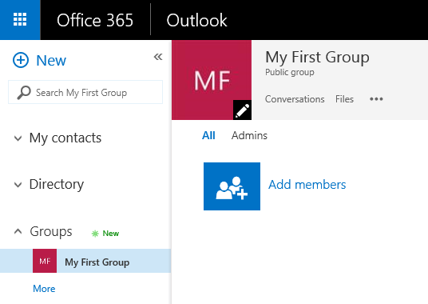

1. Close all windows and prepare to shut down your Virtual Machine…

You have now completed building the VM that can be used as the starting point to complete the lab exercises for the Office 365 Developer courses offered by Critical Path Training. You may now shut down the VM in preparation for the course start.

To shut down the VM press **Windows Key + I** and then on the Settings window select the **Power** button.  
(Note: it is always a good idea to take a backup of this VM Image just in case you would like to try something again after you begin the course)